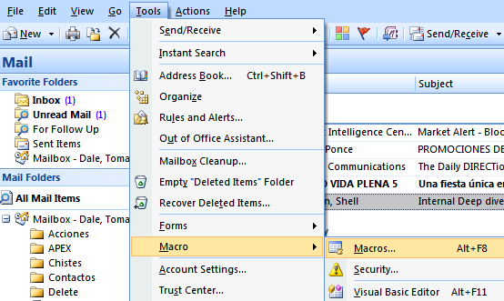
ALT – F11
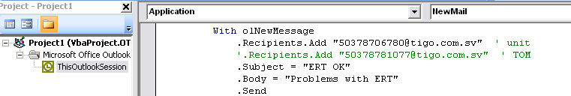
Private Sub Application_NewMail()
Dim olNS As Outlook.NameSpace
Dim olMail, olNewMessage As Outlook.MailItem
On Error Resume Next

Set oFolder = GetNamespace("MAPI").GetDefaultFolder(olFolderInbox)
'For Each oNewItem In oFolder.Items.Restrict("[Unread] = 0")
For Each oNewItem In oFolder.Items

For Each oNewItem In oFolder.Items

If oNewItem.From = "Global Communications" And oNewItem.UnRead Then
Set olApp = Outlook.Application
Set olNewMessage = olApp.CreateItem(olMailItem)

With olNewMessage
.Recipients.Add "tomdaler@yahoo.com"
.Subject = "Global Communications"
.Body = oNewItem.Body
.Send
End With
oNewItem.UnRead = False
End If
Next

End Sub

Enabled macros

